# JUnit Testing Exercises

Exercise 1: Setting Up Junit

Code:

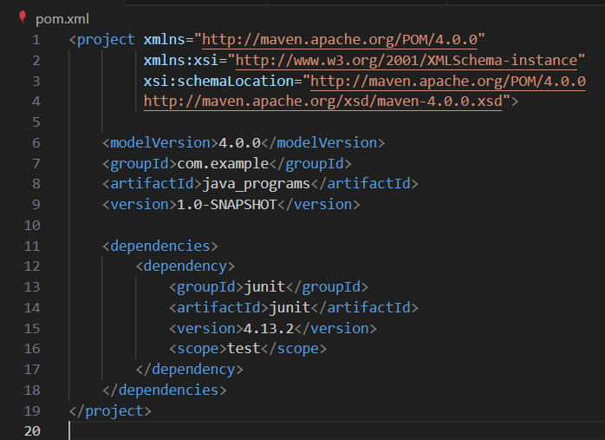

Exercise 2: Writing Basic JUnit Tests

Code:

: 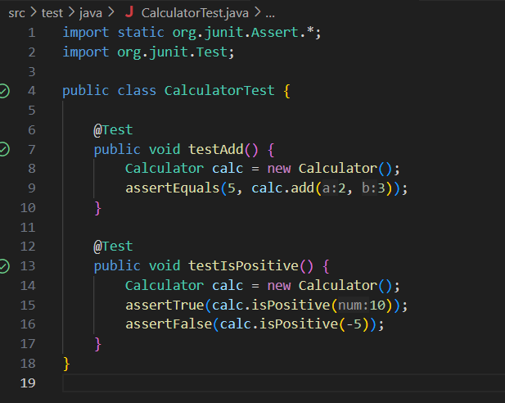

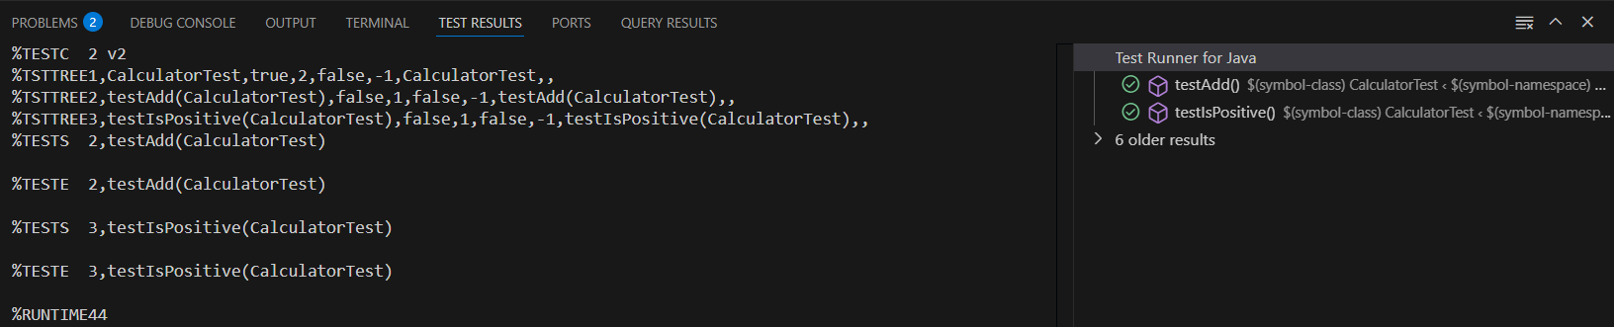

Exercise 3: Assertions in Junit

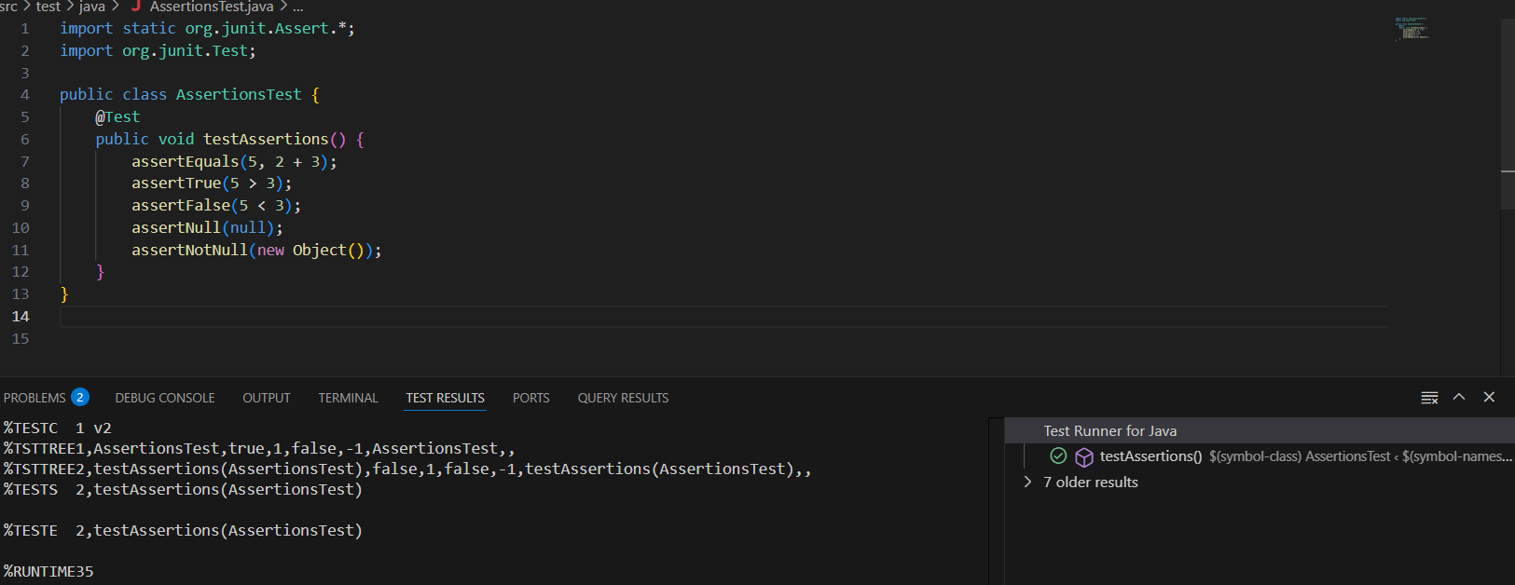

Exercise 4: Arrange-Act-Assert (AAA) Pattern, Test Fixtures, Setup and Teardown Methods in Junit

